**A**

**PROJECT REPORT**

**ON**

**“ONLINE FRUIT’S SHOP”**

**DELIGHT FRUIT’S Farming, Jalgaon.**

***Submitted in the partial Fulfilment of the Requirements***

***of***

**MASTER OF COMPUTER APPLICATION**

**Submitted By**

**WARKE PURVA DILIP**

**Roll No : - 136**

**PRN NO : - 2018015400314917**

**Mobile No: - 9075888375**

**Email ID: warkepurva@gmail.com**



**www.imr.ac.in**

**K.C.E Society’s**

**Institute Of Management & Research, Jalgaon**  
**Affiliated to KBC North Maharashtra University, Jalgaon  
NAAC Accredited**

**Academic Year - 2021-22**

**Guided By : - Prof. Ankita Tiwari**

**Acknowledgement**

I would like to express my special thanks of gratitude to my guide

Prof.Ankita Tiwari who gave me the golden opportunity to do this wonderful project

on the topic website on “Delight Fruit's Shop”.

which also helped me in doing a lot of Research and I came to know about so many new things I am really thankful to them.

Secondly I would also like to thank my parents and friends who helped me a lot in finalizing this project within the limited time frame.

**Warke Purva Dilip**

**(F.Y.M.C.A)**

**Index**

|  |  |
| --- | --- |
| **Sr.** | **Chapter name** |
| 1. | Introduction |
| 2. | Market Potentials / Strategy |
| 3. | Advantages and Disadvantages |
| 4. | Scope |
| 5. | User Manual |
| 6. | Onscreen Views |
| 7. | Input Views |
| 8. | Limitation |
| 9. | Conclusion |

**Introduction**

India had already substituted China as one of the most desirable markets for retail expansion, backed by an unshakable-growing economy, rising consumption rates, increasing urbanization and an emerging middle class. The overall market value of the Indian market has been approximated to be about US$ 650 billion in 2018, with a compound annual growth rate ( CAGR) of about 7.5% since 2000. The retail economy is projected to grow to US$ 1.6 trillion by 2026, with a CAGR of about 10%.

Even so, the modern market is predicted to increase at a healthy rate of 20% per year and traditional trade is anticipated to rise at a cagr of 10% per year. The retail industry is still very much in the infant stages.

Simultaneously, the liberalization of the Indian economy and globalization have sparked increased economic development around the spectrum of all market sectors in India. The owner has a fruit shop with all kinds of fresh fruit.

**Market Potential / Strategy**

A fresh fruit company or store is a fantastic opportunity for business owners attempting to begin a new low-investment business. Changes in lifestyle and the requirement for healthful and clean fruit are generating an increasing demand for fresh fruit in India.

The fresh fruit industry in India is largely unorganized and undiscovered. As a result, many new competitors have since been able to rapidly set up large businesses and brands such as RAW pressery and Paper Boat. Investment in equipment and raw materials may be high or low probably depends on the magnitude of the business.

However, the actual fruits business does have a low investment necessity to rapidly break even due to increased profitability. In India, with rising awareness of the worsening of health to soft drinks, the soft drink market has seen shrinking profits in the last few years and profitability is expected to drop even further in the next 5 years. For this Fruit juice drinks and colas needs fresh Fruits in large quantities.

**Advantages And Disadvantages**

**Advantages :-**

1. **Cleaning using Ultrasonic Process :-**

Cleaning of the food products like fruits is the most important thing and that's why using disinfected water needs to be considered as the most integral part in the food industry.

**2. Saves Time :-**

In today's hectic world, time is extremely important for the people and managing time for other trivial things becomes quite a burden to them, that's why doing those things online with their comfort seems a more feasible option. As the orders can be performed at one's fingertips without any hassle the time taken is extremely less as compared to the traditional method. Also, it can be considered as super beneficial because you can save your precious time and you can do shopping 24*7. Therefore shopping online to buy fruits can be more beneficial and less time consuming.

**3. Avoid the crowd and traffic : -**

Getting stuck in the traffic becomes quite annoying and the desire to do shopping gradually declines. With the ease of online shopping from comfort of your home becomes a better option than the former one.

**4. Payment Options :-**

While shopping traditionally, the customer has only one payment option which contains many hassles. But while shopping online there are multiple options like online payment, card payment and cash-on-delivery which are more appropriate for the customer.

**Disadvantages :-**

1. **Delay in Delivery :-**

Long duration and lack of proper inventory management result in delays in shipment. Though the duration of selecting, buying and paying for an online product may not take more than 15 minutes.

1. **Frauds in Online Shopping :-**

Sometimes, there is a disappearance of the shopping site itself. In addition to the above, the online payments are not much secured. The rate of cyber crimes has been increasing and customers’ credit card details and bank details have been misused which raise privacy issues.

1. **Lack of Significant Discounts in Online Shops :-**

Physical stores claim to give significant discounts when compared to online stores, this is a huge disadvantage for the older generation.

1. **Missing the Shopping Experience :-**

The traditional shopping exercise provides a lot of fun in the form of showroom atmosphere, smart sales attendants scent and sounds that cannot be experienced through a website. Indians generally enjoy shopping. Consumers look forward to it as an opportunity to go out and shop.

**Scope**

**1. Need to Increase Production to Meet Dietary Requirements :-**

The per capita consumption of fruits in India is very low e.g. USA 202kg/capital year, Pakistan 100 kg/ capital/ year and India 10 kg / capita year. The low consumption of fruits is only due to very small fraction of the total cropped area under fruits.India needs to step up the production of fruits till the country becomes self sufficient and process of fruit fall to the level at which both rich and poor can afford to buy. The prices of fruits are so high.

**2. Increasing Irrigation Facilities in Maharashtra :-**

Most of the commercial fruit tress requires perennial irrigation. The area receiving perennial irrigation which was 6% in 1960 reached a level of 12.5 to 13% today. By exploiting all the resources the maximum area that can be brought under irrigation would be 25% of the total cropped area. Thus, there is still scope to increasing irrigated area in near future as government is giving priorities to such to works. This would be definitely help to increase area under fruit crops.

**3. Increasing Urbanization and Charge in Food Habits :-**

Increasing urbanization due to industrial growth has increased demands for fruits. Change in food habits is also being noticed due to education and assured income which has also helped in increasing demands for fruits.

**4. Increased Transport Facilities :-**

Most of the fruits are highly perishable, having less storage life and need quick disposal after harvest. Lack of good transportation system was one of the major constraints in are expansion of fruits. However, now a days quick transport facilities by road rail and air are available enabling growers to transport fruits, to long distance markers in good condition in a short period of time. Increasing in facilities in transport facilities provide scope for fruit farming.

**5. Availability of Loan Facilities :-**

Fruit crops being capital intensive, lack of capital was one of the major bundles in the expansion. Now a days there are several cooperative and commercial banks providing finance for fruit farming which has increased the scope for it.

**User Manual**

**User Requirements :-**

Every user interacts with the system with some needs and requirement such as :-

* Basic knowledge of computer should be required.
* User should know basic knowledge about the computerized Courier Services i.e. which are the modules of the computerized system, what is the function of each module.
* Data security and priority is not to be ignored.
* Every user must know the function of each Master entry, Transaction entry and Reports.
* In short, operating environment about the computerized “Delight Fruit Shop” must be familiar to the user.

**Onscreen Views**

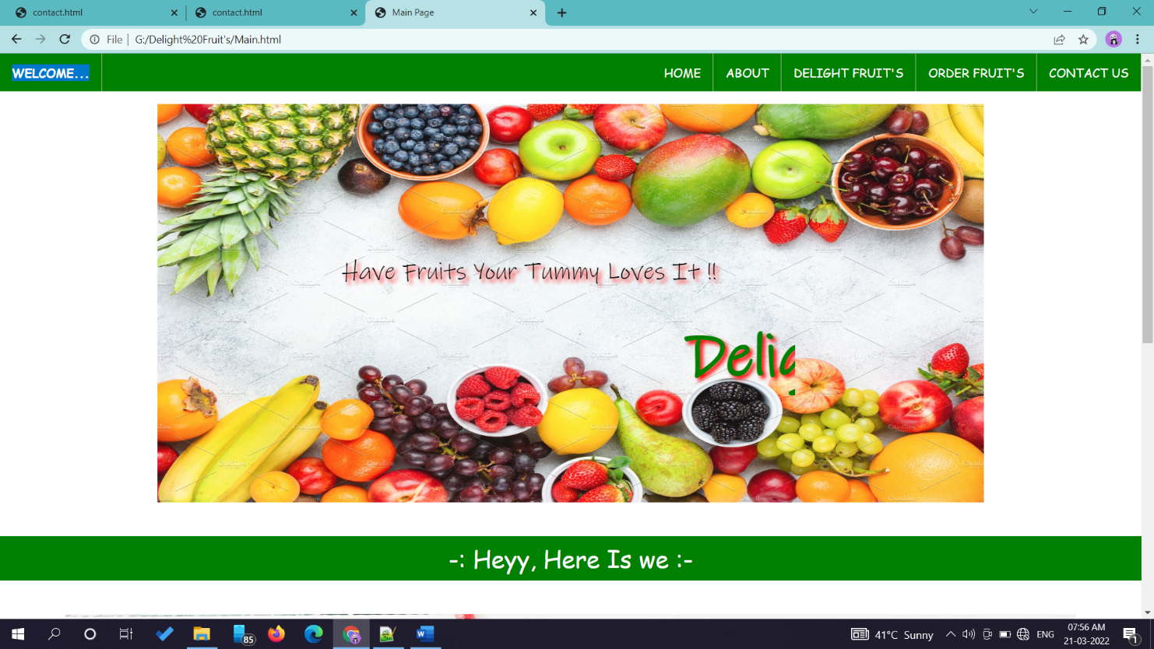**-: Main Page :-**

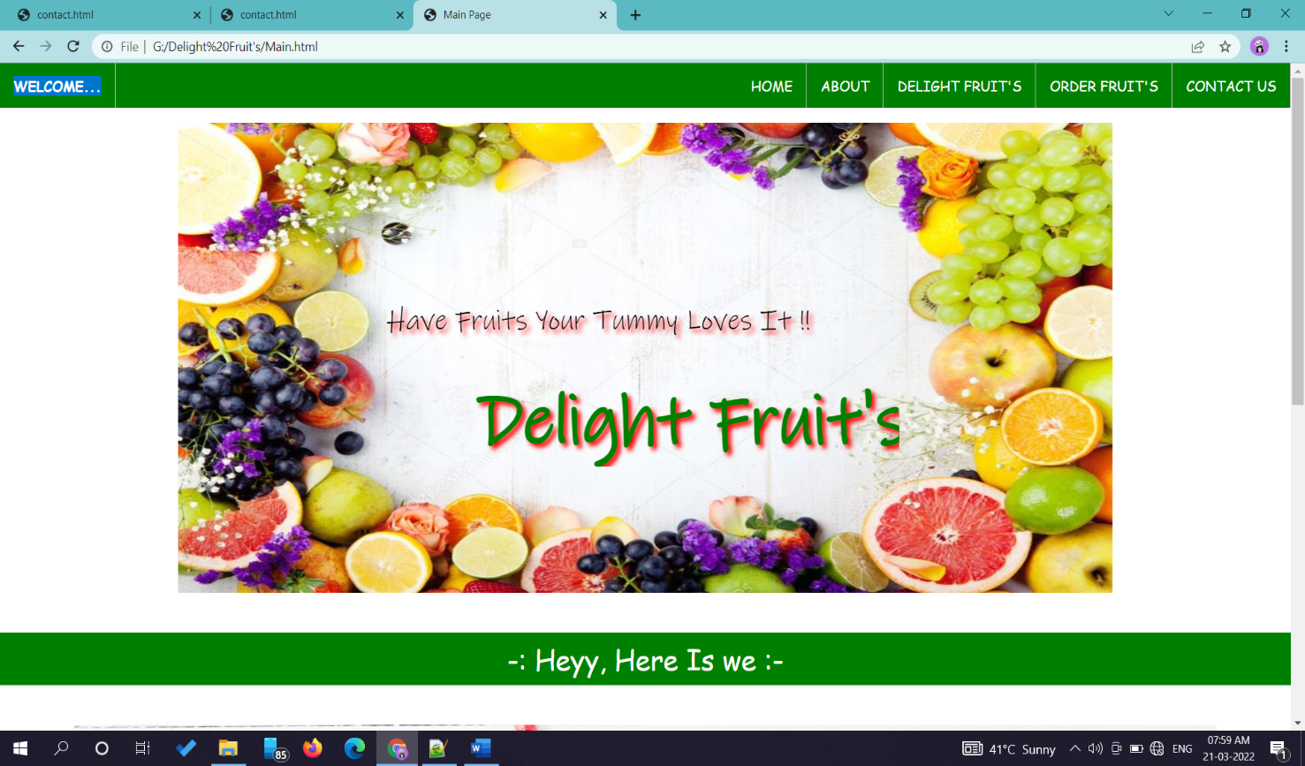

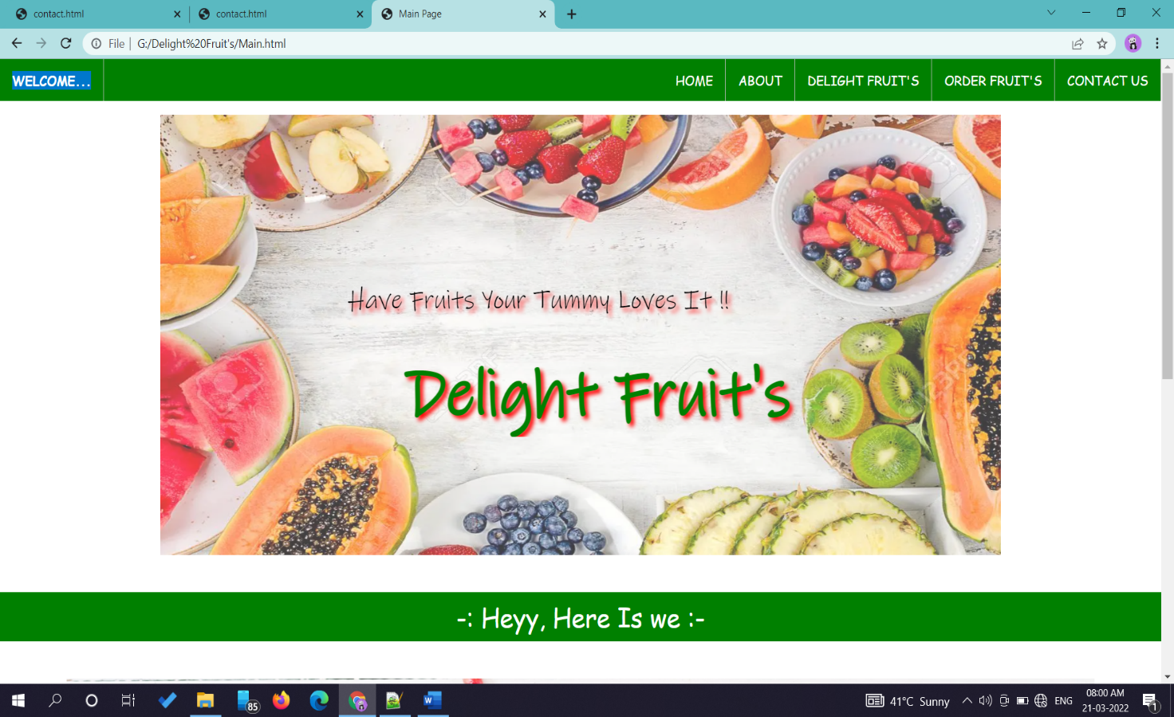

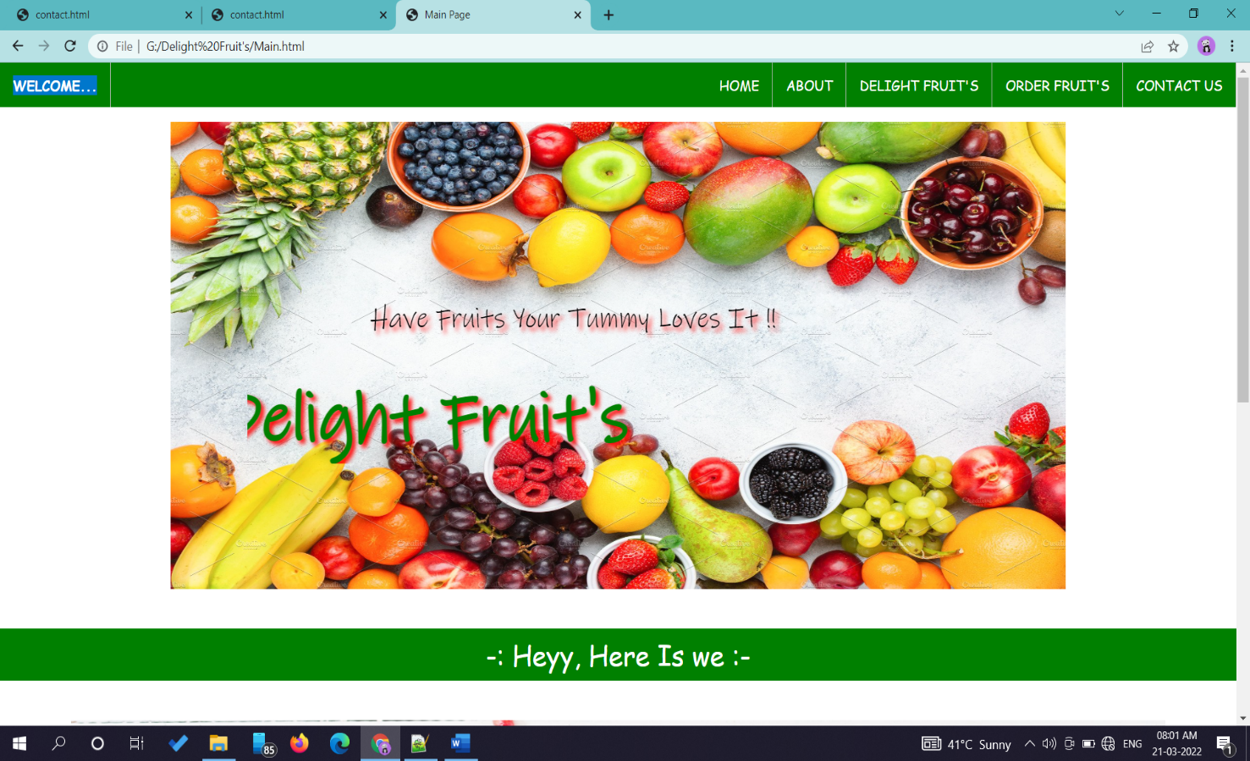

**-: About Page :-**

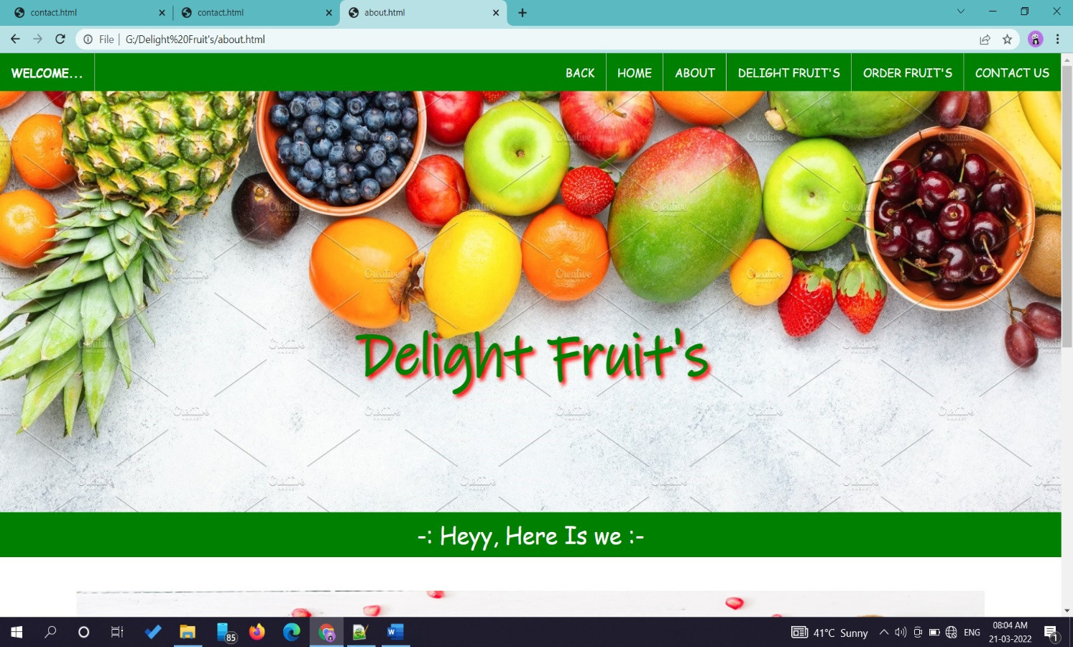

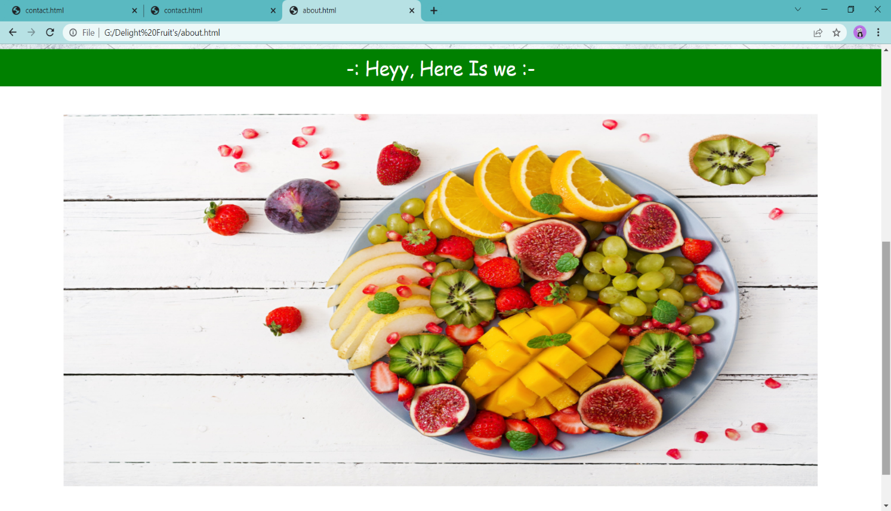

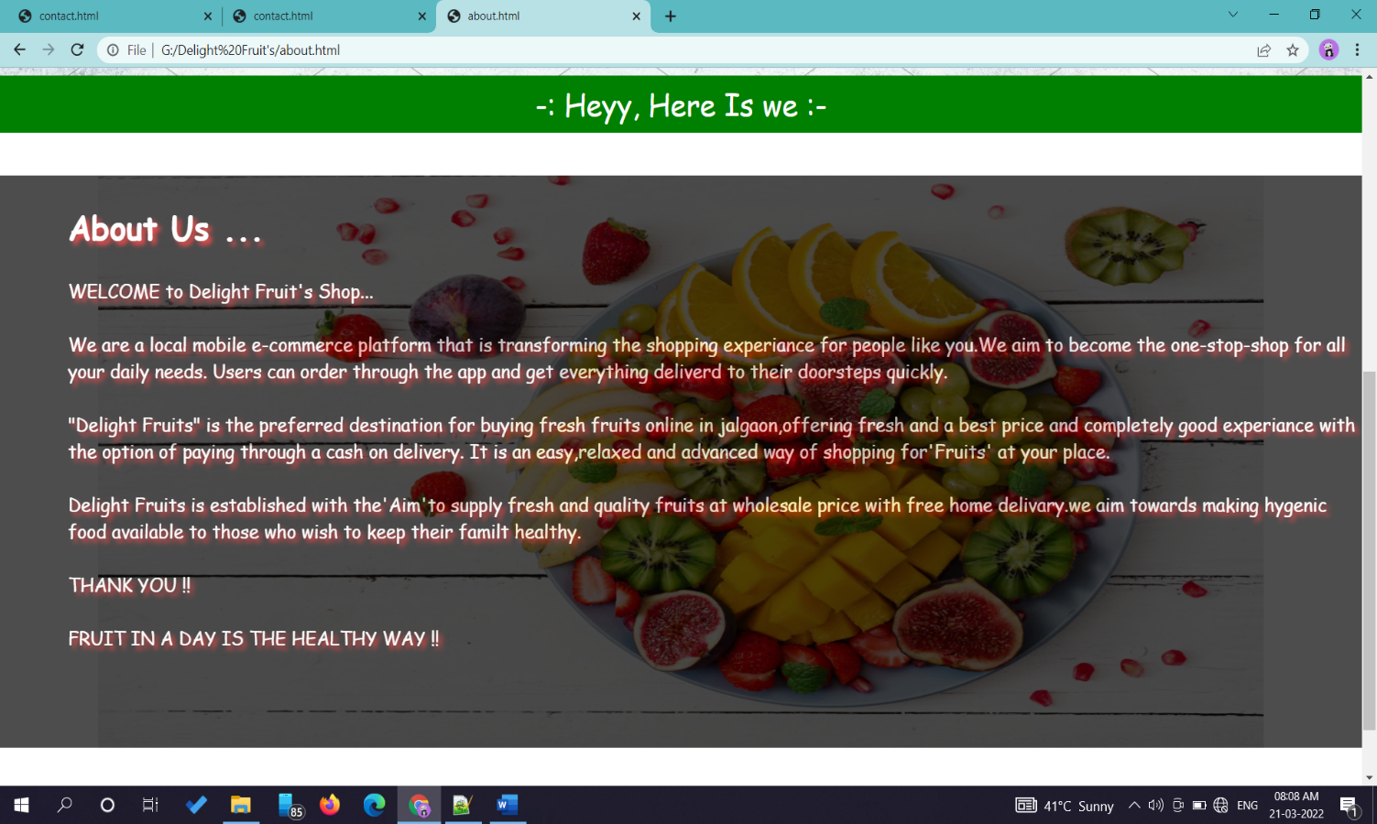

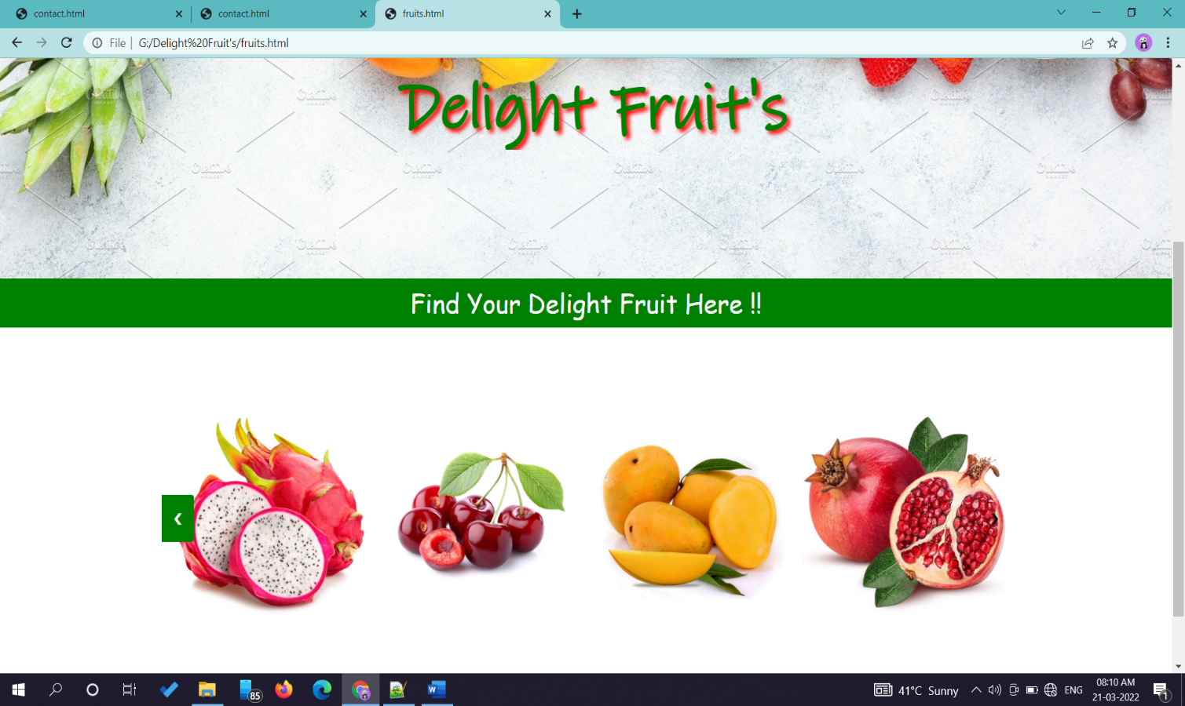**-: Fruit’s Page :-**

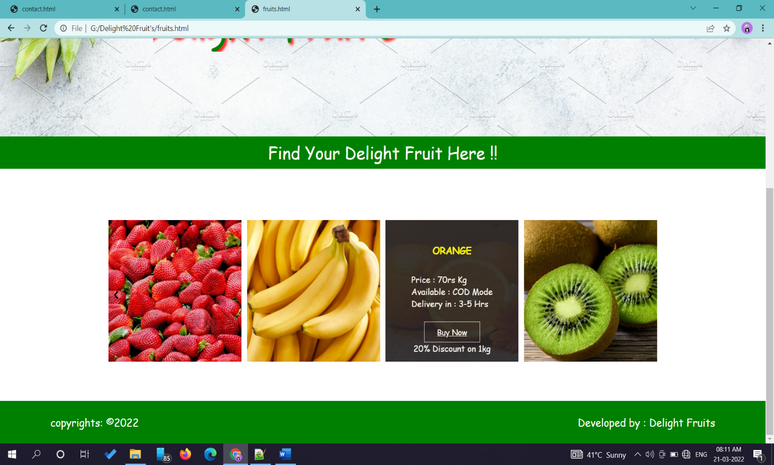

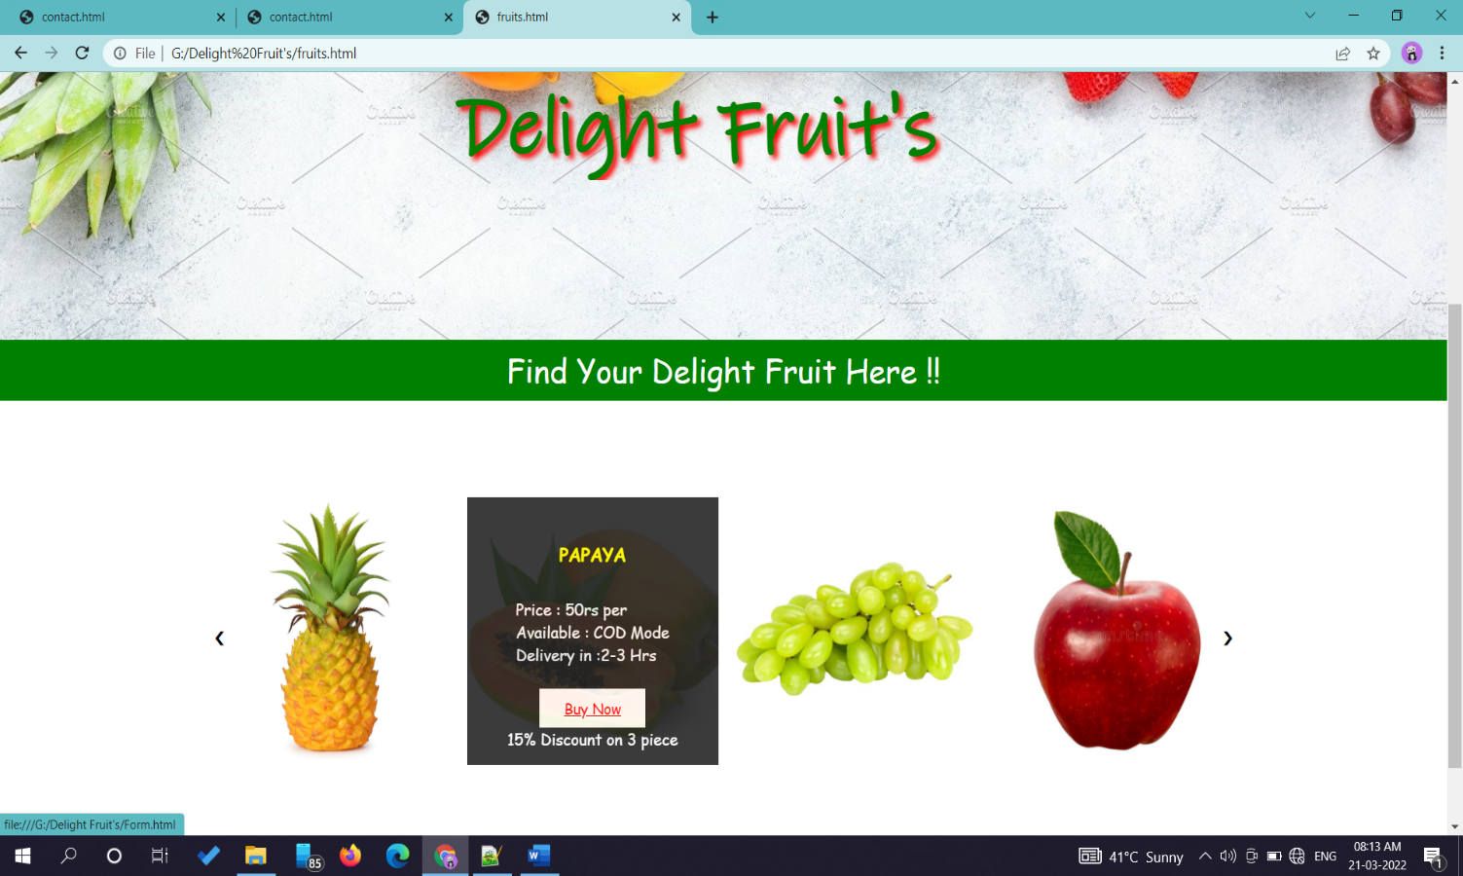

**-: Order Page :-**

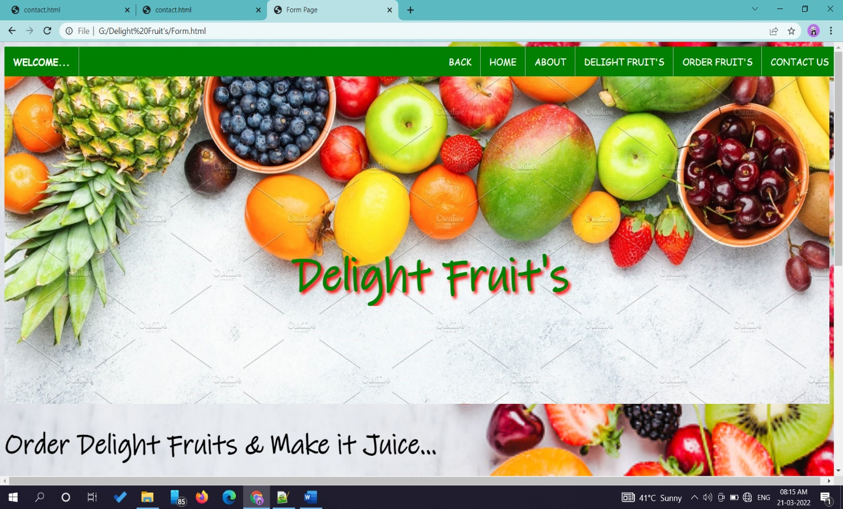

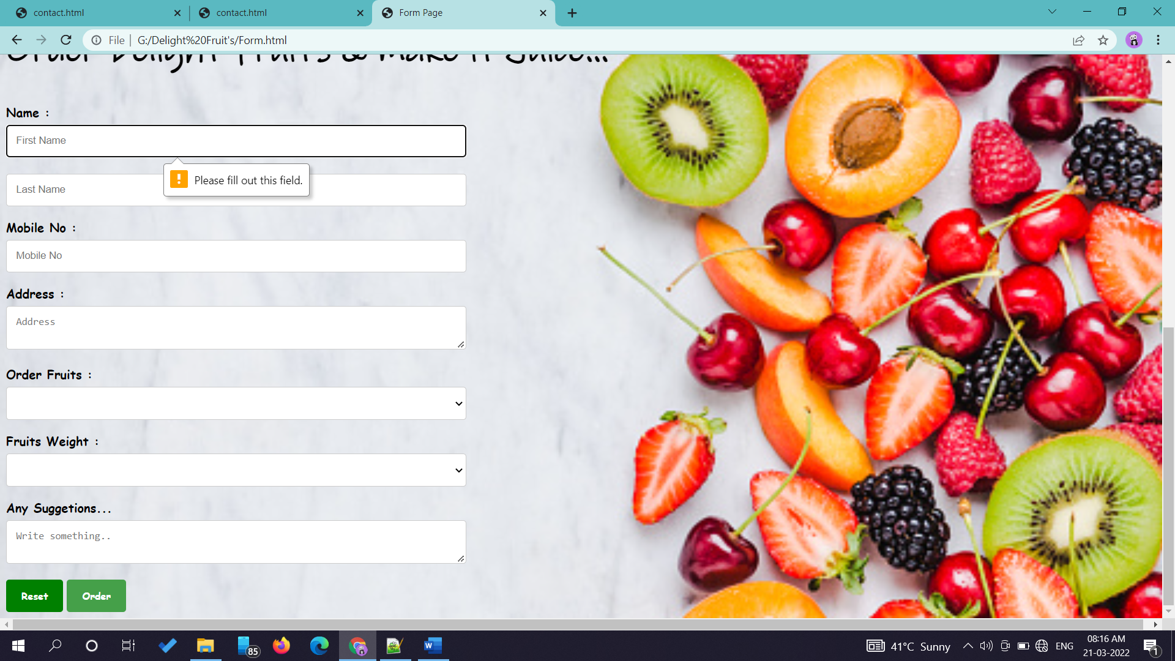

**-: Contact Page :-**

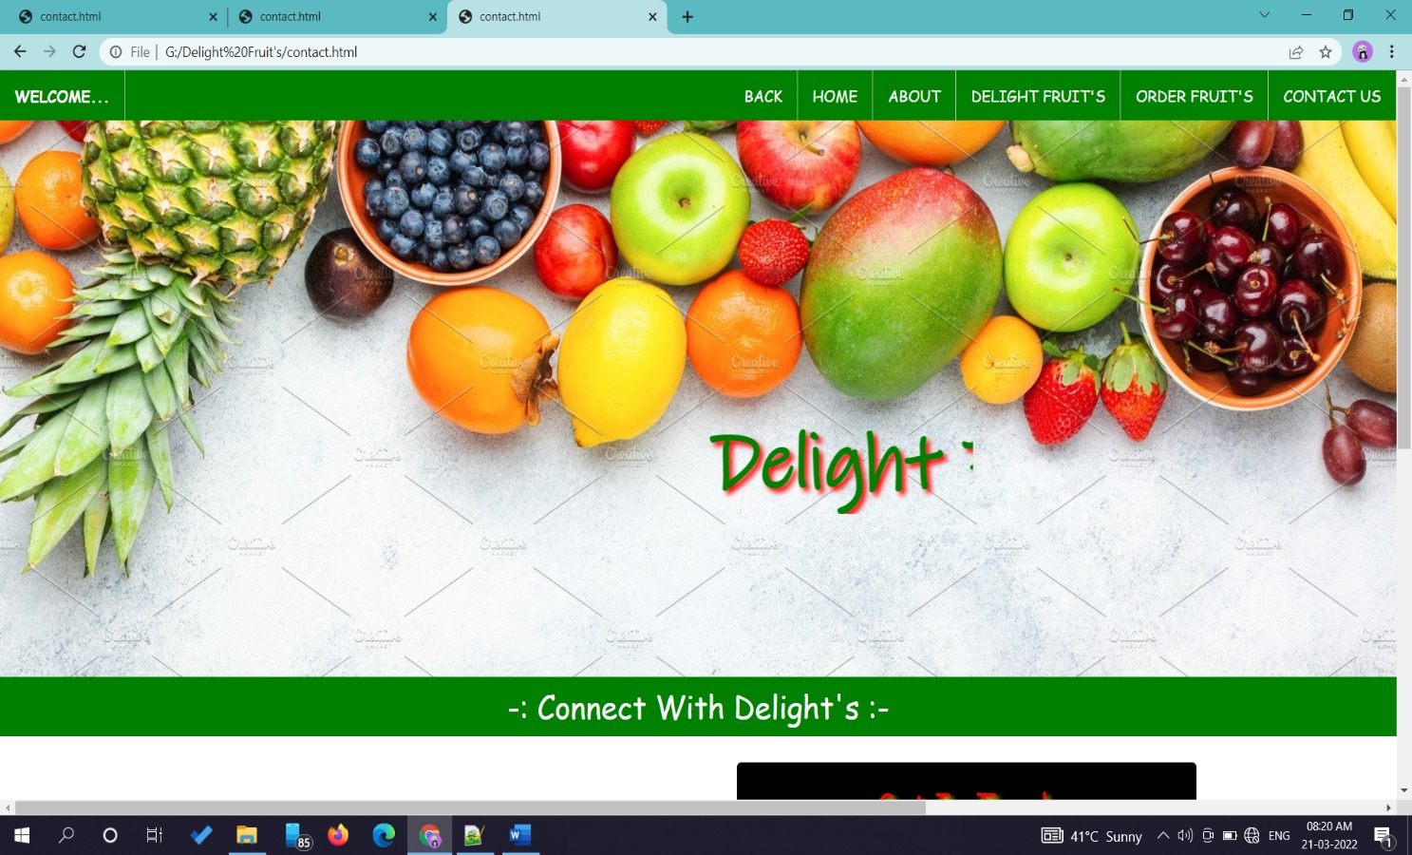

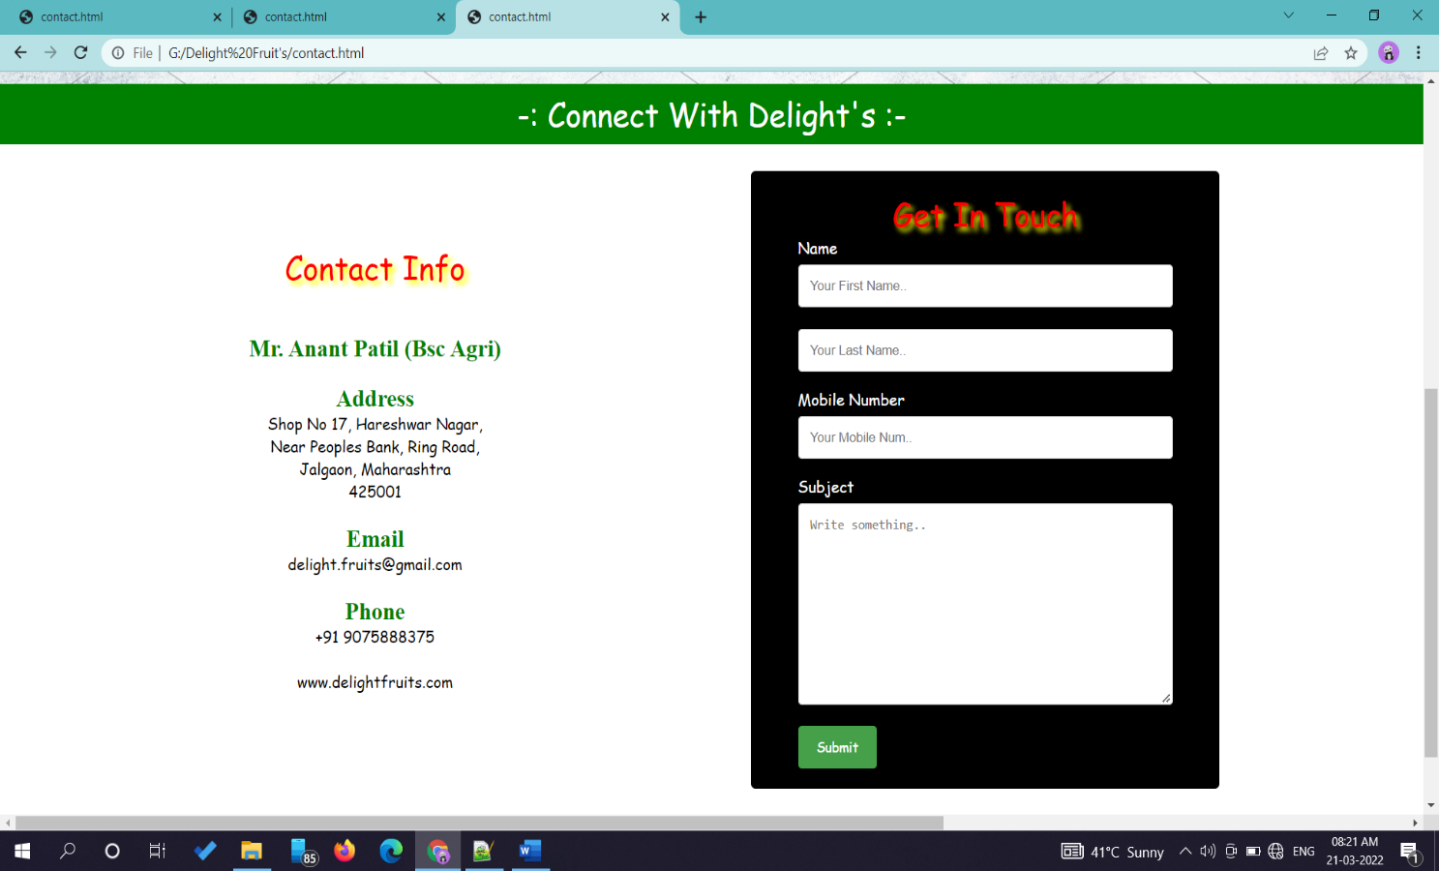

**Input Views**

**Limitations**

• Its deployment is little bit hard one.

• Complex Pages with Performance issues.

• The managed code can be slower than native code.

• Server maintenance is needed.

**Conclusion**

The Website quality depends upon the phases included in the system. An application website should be easy to operate & understand. A high Quality website product satisfies the user requirements regarding design specification & maintains flexibility as well. These aspects are accomplished in designing and developing this Particular websites "Delight Fruit’s Shop".

* User Friendly- The system is totally user friendly & easy to operate & understand.
* No Duplicity- As data is completely normalized, so that no duplicate entries exists.
* Menu driven- This system is totally menu driven for the best result.